**SUMMARY**

CONTROL OF REVISIONS ……………………………………………………………………………….2

OVERVIEW ………………………………………………………………………………………………….2

**PROCESS VOLUME …………………………………………………………………………………….2**

**OPERATION PREMISES ……………………………………………………………………………….2**

**TARGET SYSTEM ……………………………………………………………………………………….3**

**SYSTEMS CREDENTIALS ……………………………………………………………………………..3**

PROCESS DIAGRAMS …………………………………………………………………………………...4

PROCESS DETAILS ……………………………………………………………………………………….5

BUSINESS RESTRICTION ………………………………………………………………………………..6

BUSINESS EXCLUSION …………………………………………………………………………………..6

# CONTROL OF REVISIONS

| ***Version*** | ***Date Issued*** | ***Description*** | ***Author*** |
| --- | --- | --- | --- |
| *1.0* | *30/06* | *Initial Document* |  |

# OVERVIEW

The process automates the inspection workflow in electrical substations. Technicians fill out checklists through a digital form, and the data is stored in spreadsheets. A Python robot processes the information, generates PDF reports, updates records, and sends email alerts when failures are detected. This eliminates manual rework, improves operational visibility, and speeds up incident response.

## PROCESS VOLUME

| **Description** | **Value** |
| --- | --- |
| Volume / Year | 365 |
| Manual Handling Time (min) | 40 min/inspection |
| Exception Level | High |

## OPERATION PREMISES

**Execution Time:** Every day at 10:00 AM, can be manually executed if there are any critical situations that need to be handled out of the ordinary execution time.

**Execution Days:** Inspections are conducted **7 days a week**, especially in high-demand areas or critical infrastructure zones.

**Average Duration:** The estimated time to complete one inspection is **20 min**

**Systems:** Windows/Linux/macOs, Python 3.10+.

## TARGET SYSTEM

| **System** | **Description** | **Version** |
| --- | --- | --- |
| Local Machine | Runs the standalone Python application built with Tkinter. Used by technicians to fill out digital checklists | Windows 10+ / Linux / macOS |
| Python Runtime | Executes the Python application | Python 3.10+ |
| Pandas Library | Processes inspection data in-memory and exports to Excel | Latest (e.g., 2.x) |
| OpenPyXL Library | Used for writing and appending. files for inspection data.xlsx | Latest (check via import openpyxl; print(openpyxl.__version__)) |
| FPDF Library | Used to generate PDF reports of the checklist. | 1.7.2 or latest |
| Local File System | Stores outputs: Excel, PDFs, and incident photos | N/A |
| Tkinter GUI Framework | Provides the offline checklist interface. | Built-in with Python |
| PyInstaller (Optional) | Packages the app into a standalone .exe for Windows deployment. | 5.x+ (or latest) |

## 

## SYSTEMS CREDENTIALS

| **System** | **Credential** |
| --- | --- |
| Local File System | Not required |
| Python Runtime | Not required |
| GUI (Tkinter) | Not required |

# PROCESS DIAGRAMS

AS-IS Process (Current Manual Process):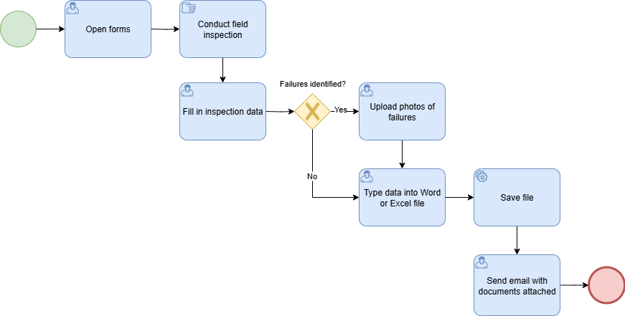

TO-BE Process (New Digital Process):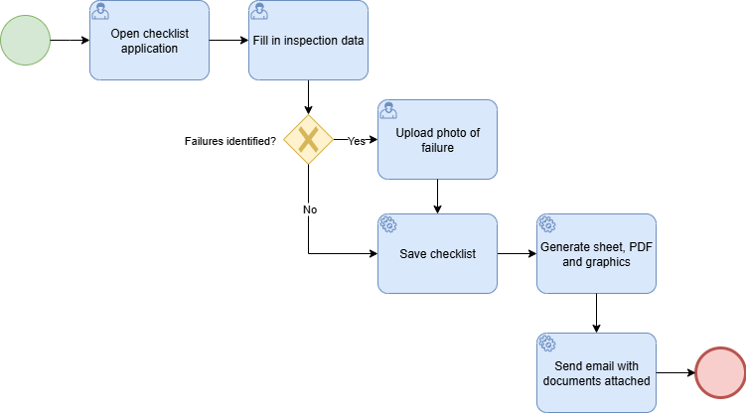

# PROCESS DETAILS

**Open browser and enter the checklist link:**

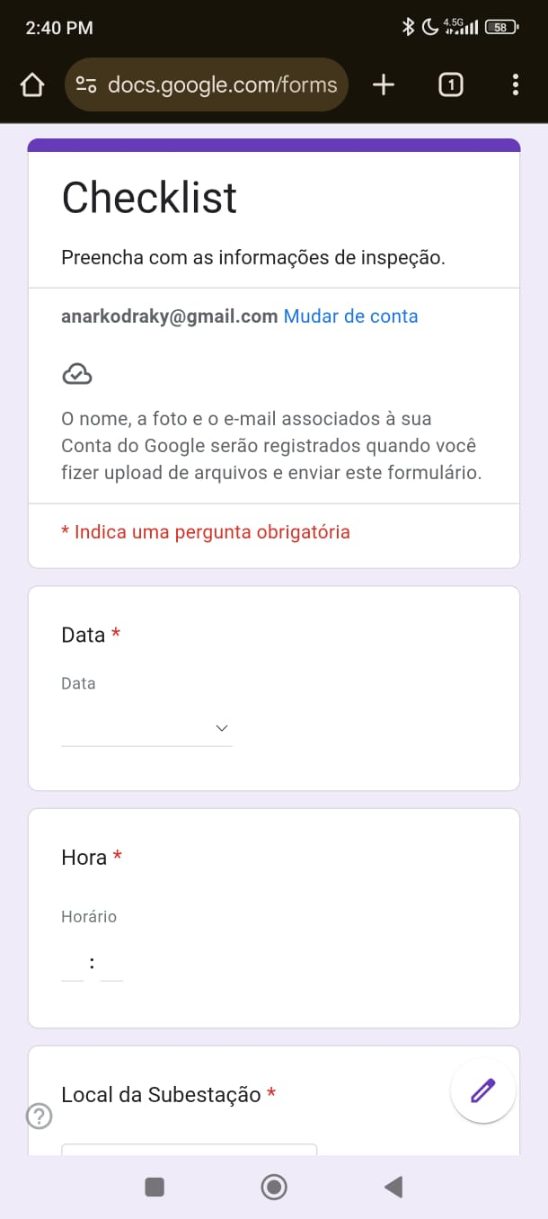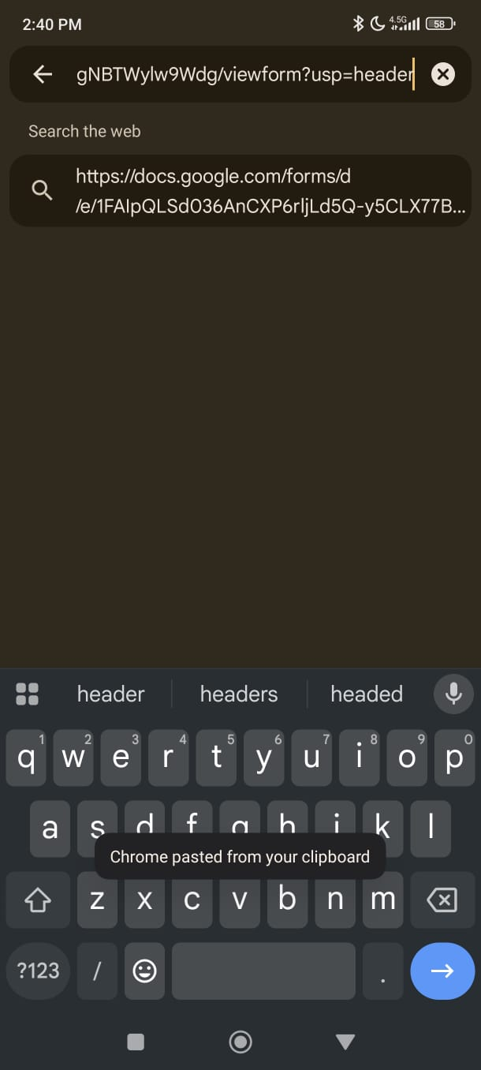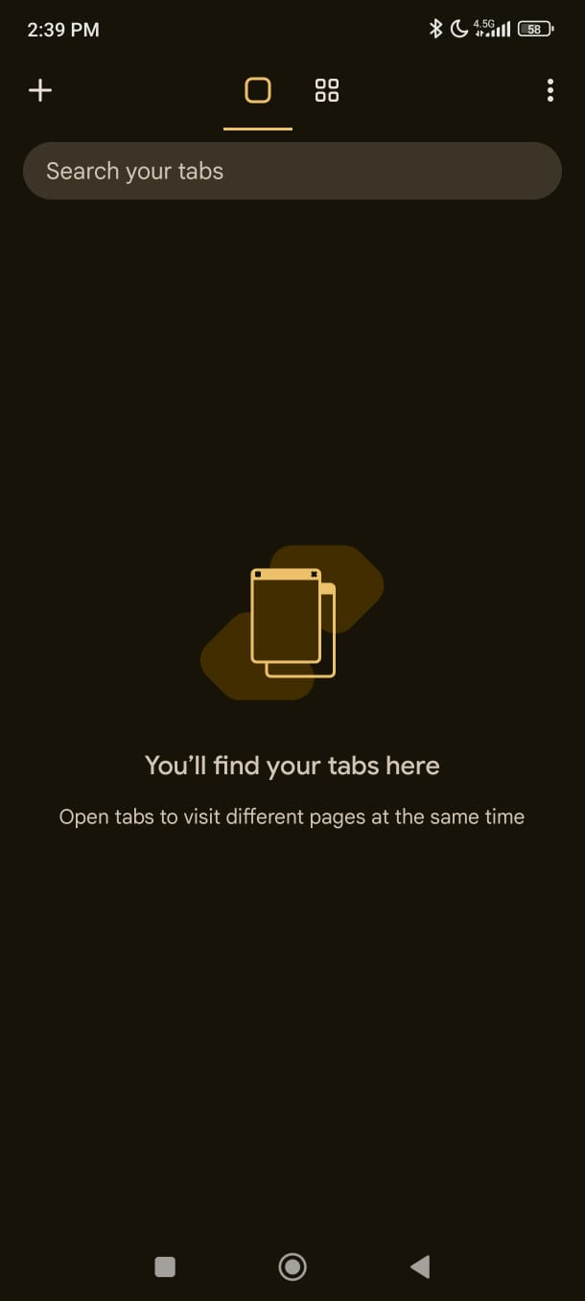

**Filling Date and Time:**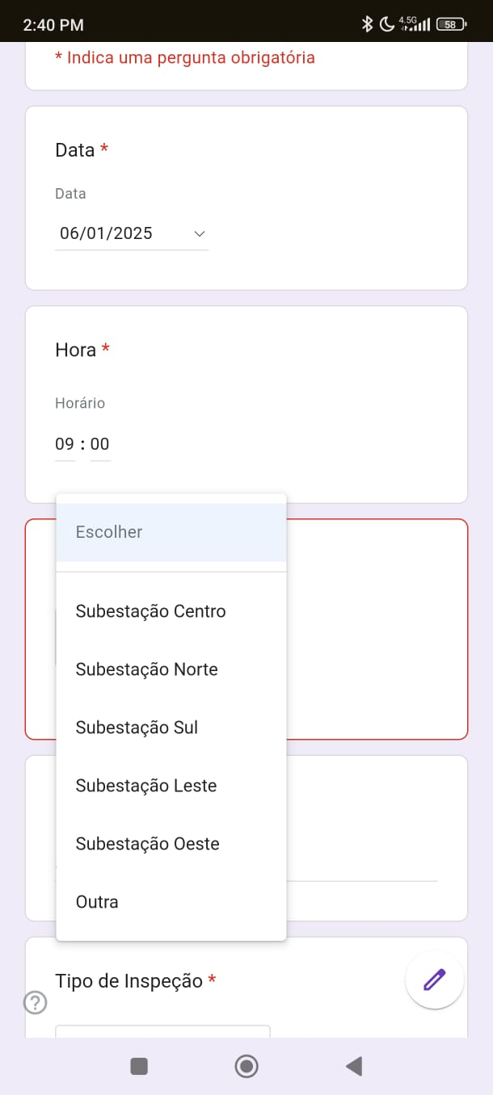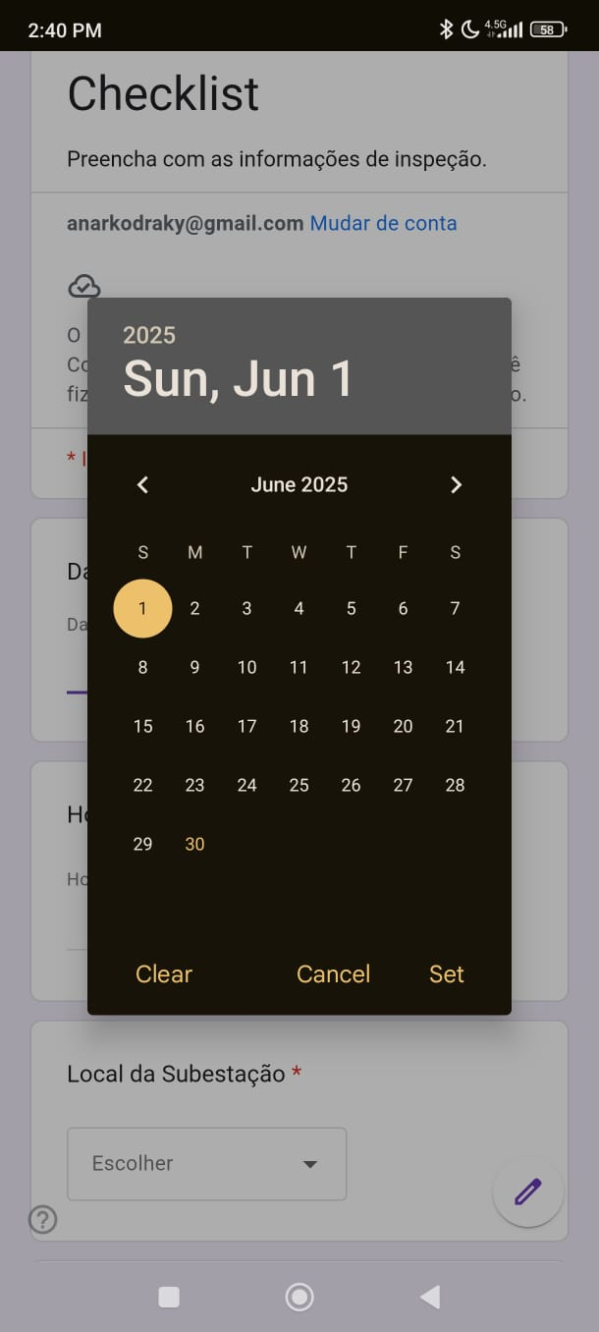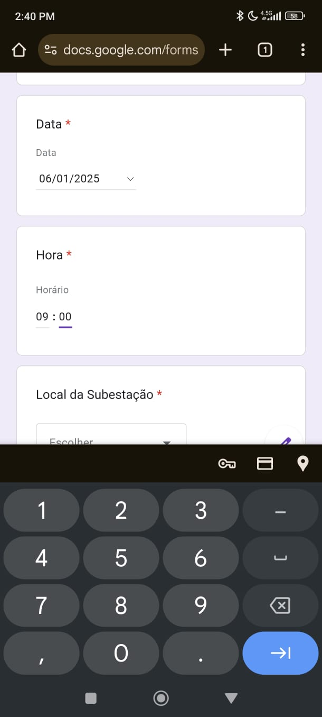

**Filling forms:**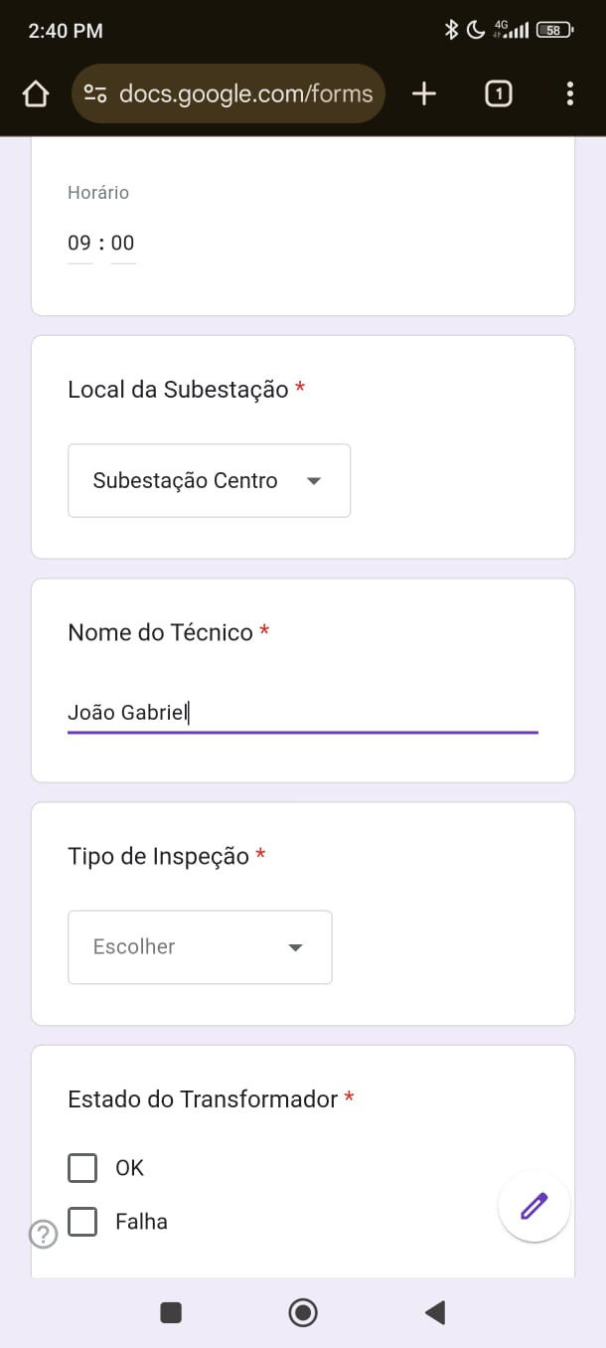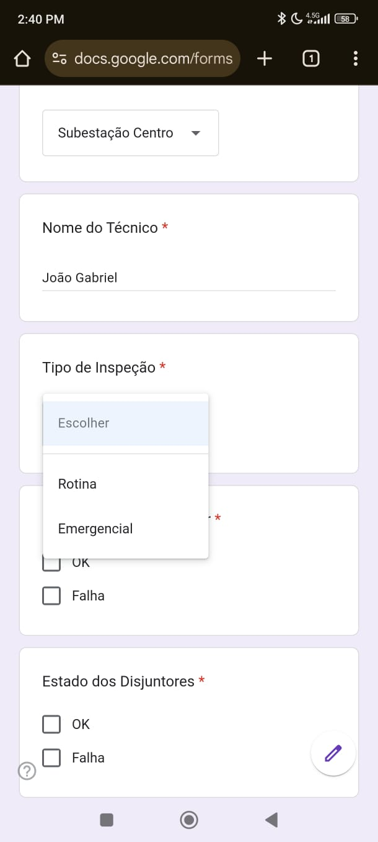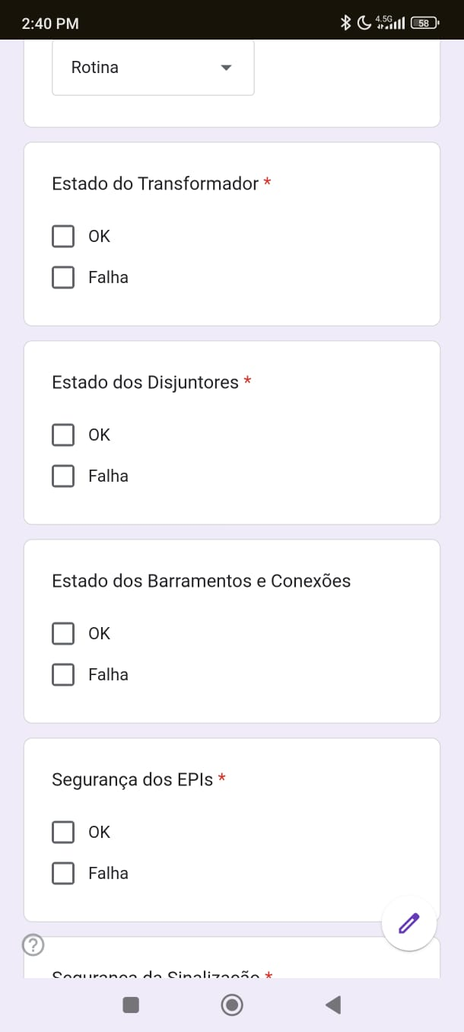

**Checking Equipment and Security:**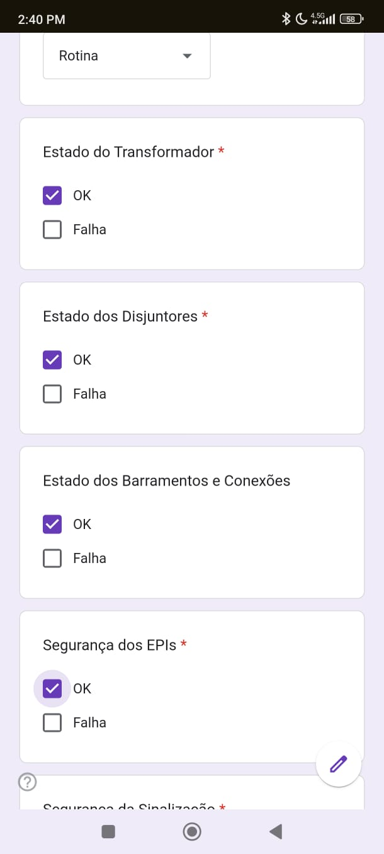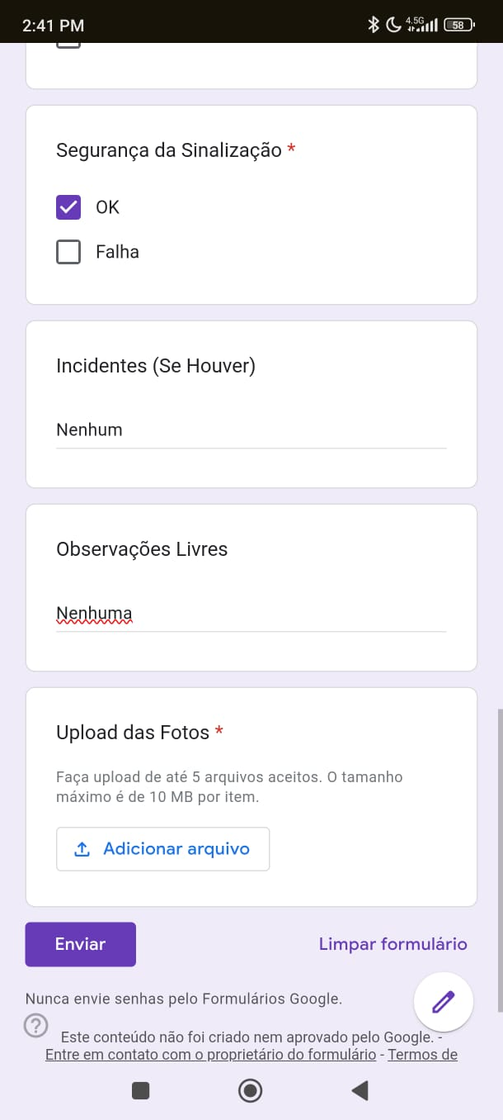

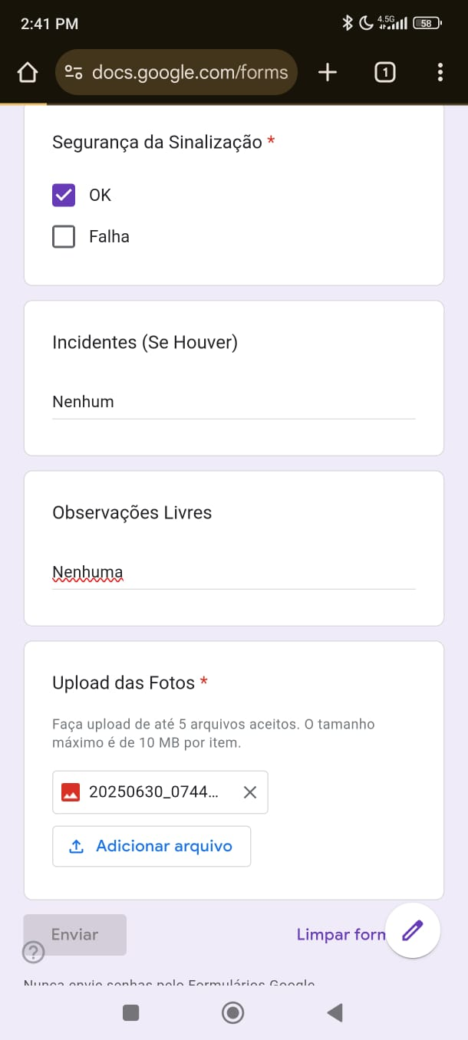

**Forms sent:**

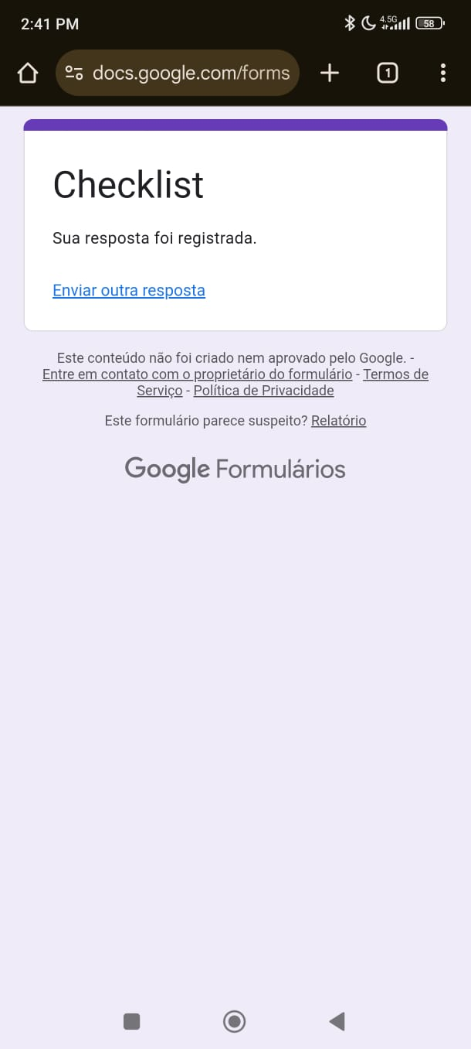

**Data received from forms:**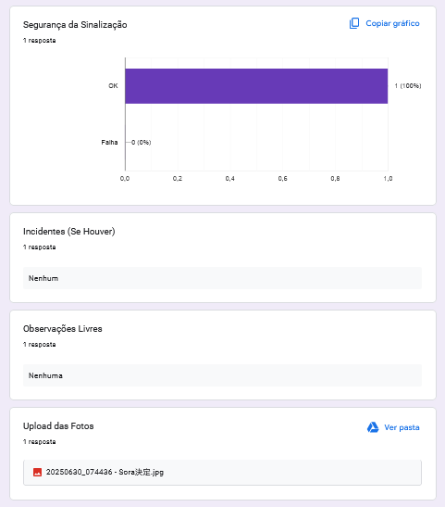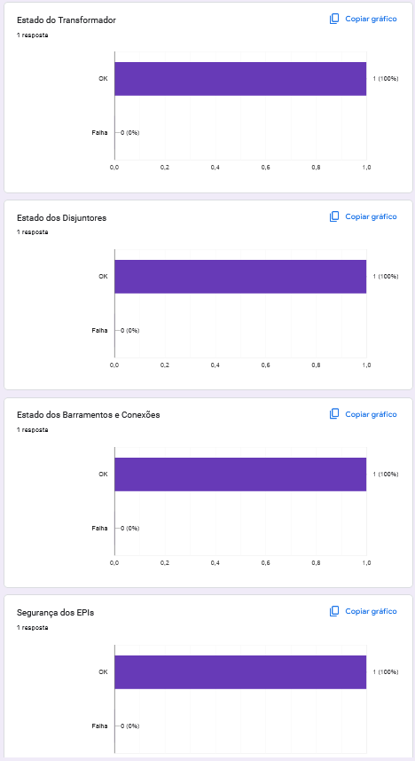

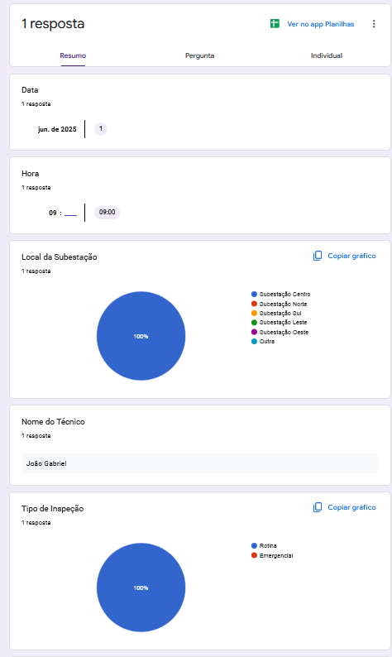

**Sheet filled on Excel:**

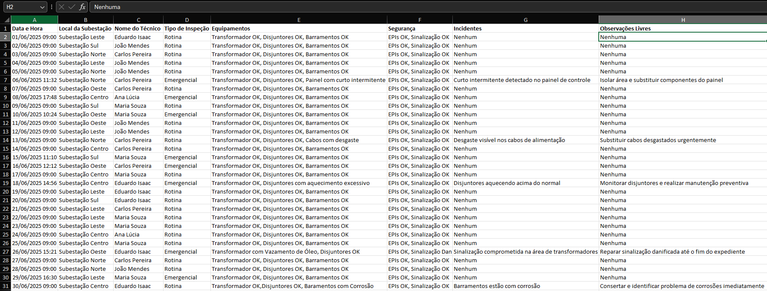

**Save xslx file:**

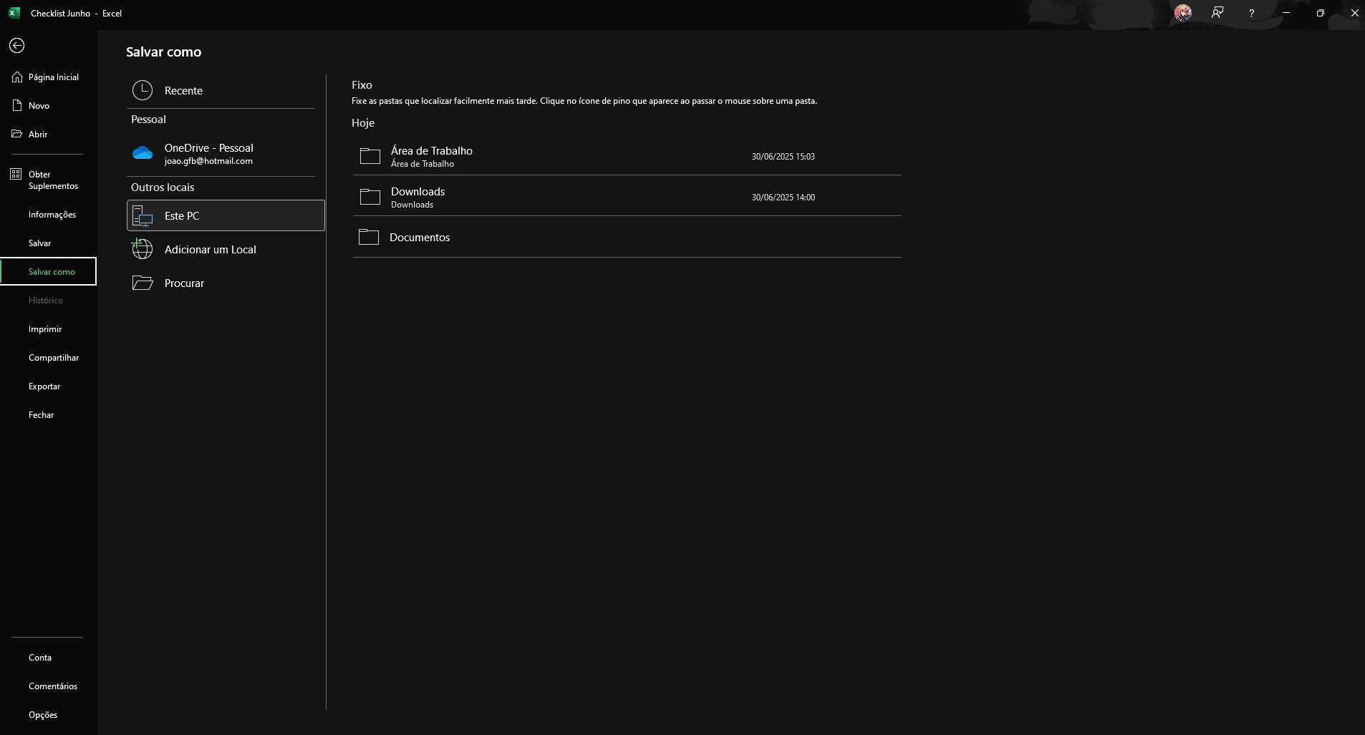

**Open browser:**

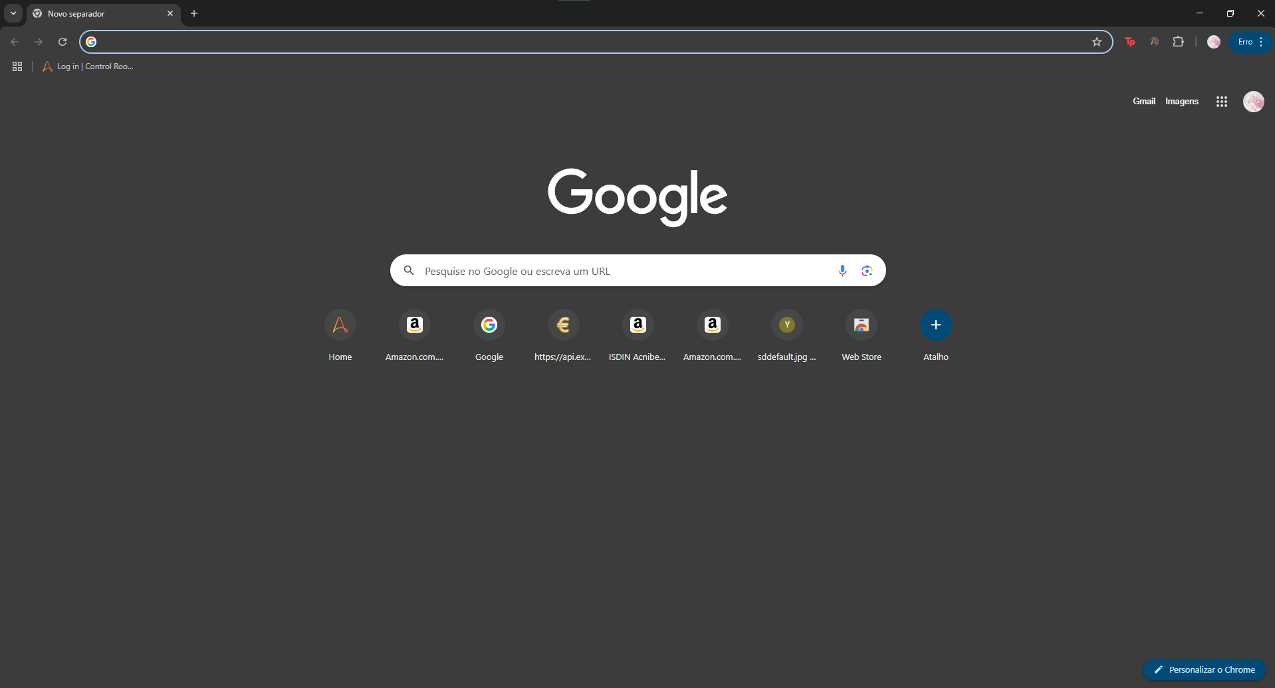

**Search “Gmail”:**

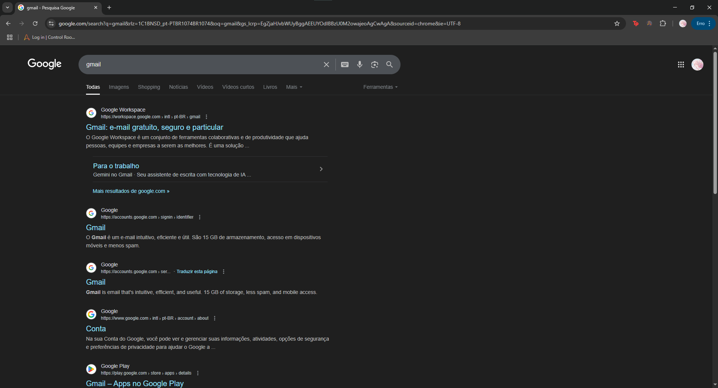

**Open Gmail:**

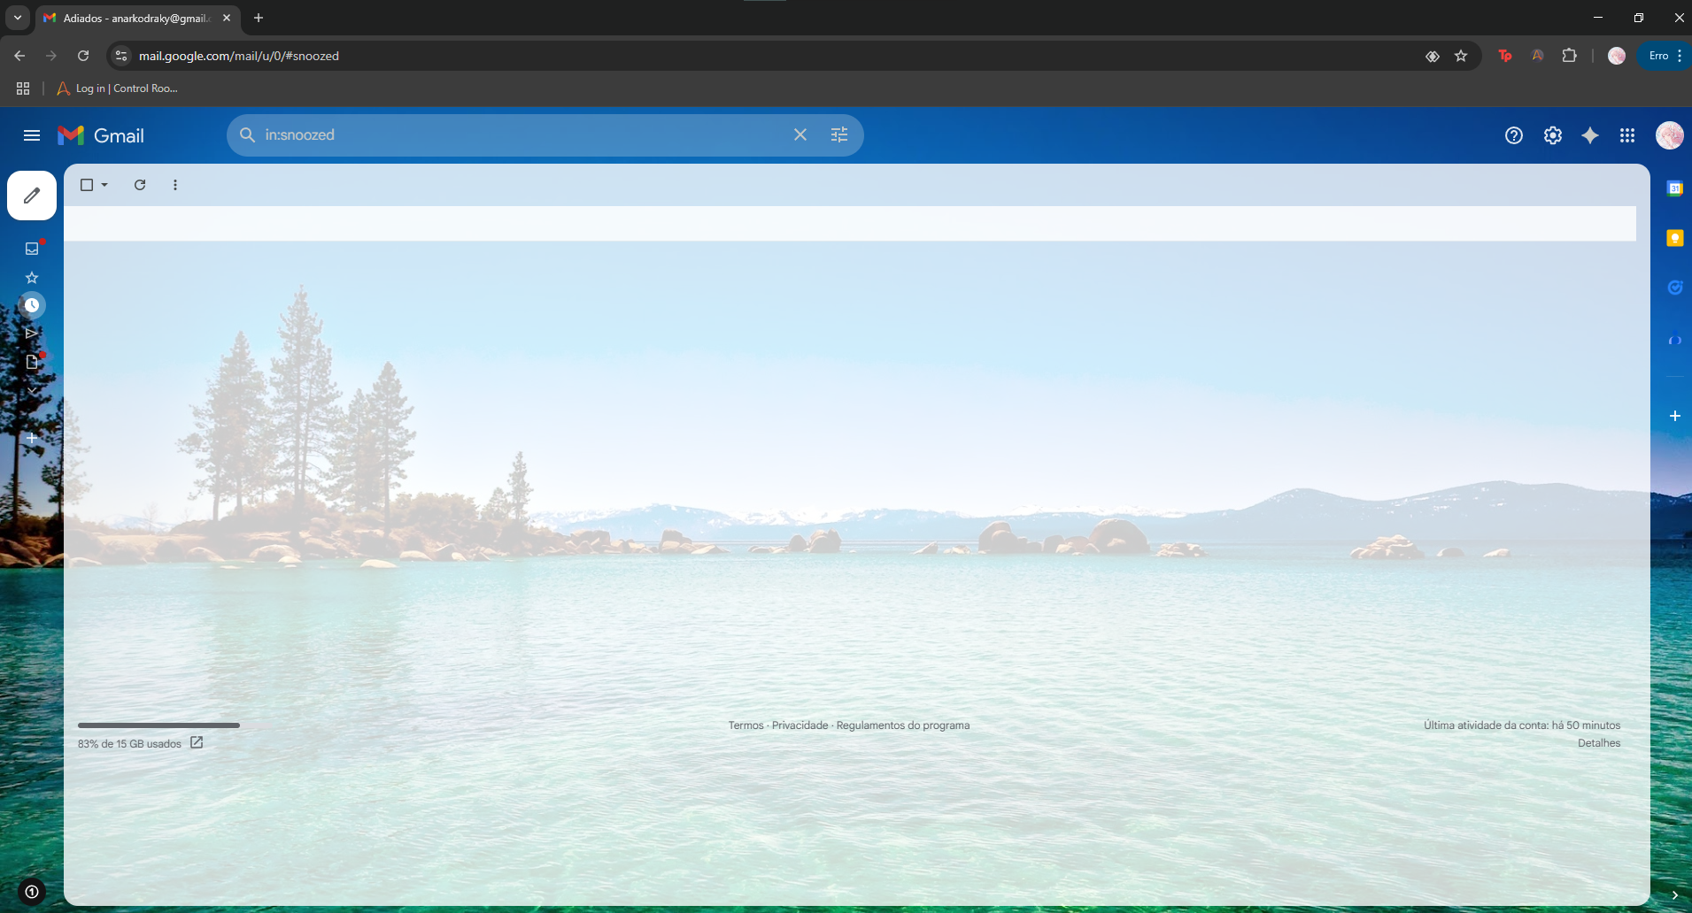

**Send a new mail:**

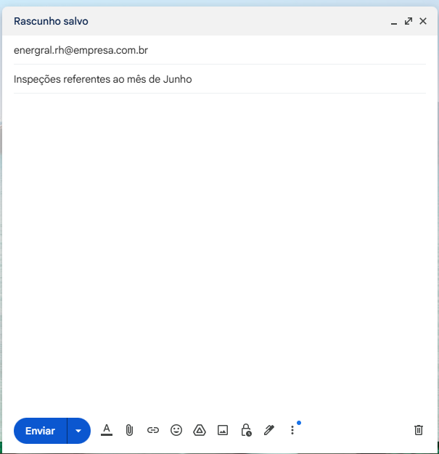

**Attach the xlsx file:**

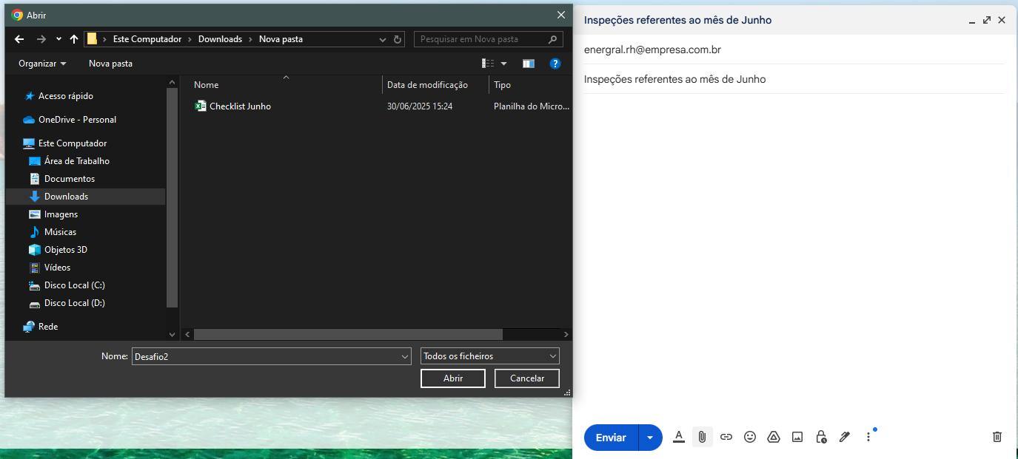

**Send mail:**

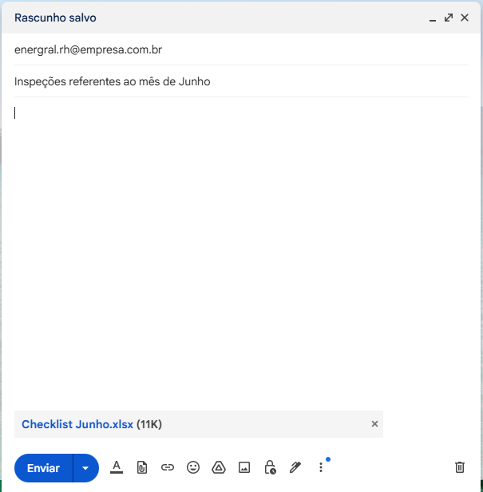

**Mail sent:**

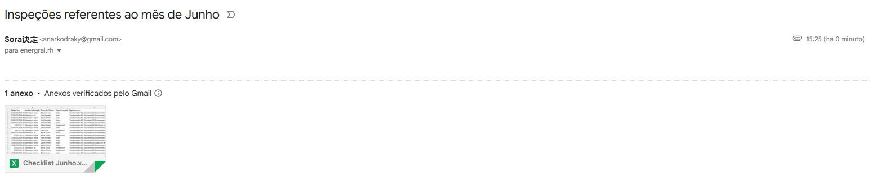

# BUSINESS RESTRICTION

**Offline Operation:** No internet required for field inspections;

**Local Storage:** Data persists even if app crashes;

**Compatibility:** Windows 10+/Linux/macOs, Python 3.10+;

**Execution:** Daily at 10:00 AM (manual triggers for emergencies)

# BUSINESS EXCLUSION

**No Cloud Sync:** Google Sheets/databases excluded;

**No Email Alerts:** SMTP functionality is commented out;

**Desktop-Only:** Not optimized for smartphones;

**Language:** Portuguese-only Ui (English optional)